Mini Review 1.1-1.2 Name: Date:
Multiple Choice – Circle the letter corresponding to the best answer for each question (1 point each).
Use the table for questions 1 to 4:
A sample of 100 adults was surveyed. They were asked if they regularly watch NFL football games. They were also asked if their favorite team had won the Super Bowl within their lifetime.
 | Favorite Team Won | Favorite Not Won
Watch NFL | 22 | 53
Don't Watch | 13 | 12

- What percentage of people surveyed watch the NFL?

- 70.7% (B) 12% (C) 53% (D) 75%

- What percentage of people surveyed don’t watch the NFL and have a favorite team has won?

- 12% (B) 25% (C) 13% (D) 37.1%

- What percentage of NFL watchers surveyed have a favorite team that has not won?

- 70.7% (B) 29.3% (C) 52% (D) 75%

- The percent from question 3 is part of

- The marginal distribution of NFL viewing.

- The marginal distribution of favorite team Super Bowl history.

- The conditional distribution of NFL viewing given favorite team Super Bowl history.

- The conditional distribution of favorite team Super Bowl history given NFL viewing.

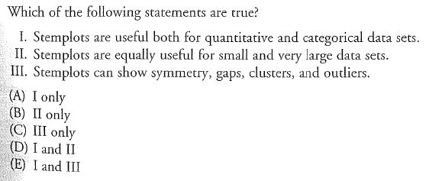

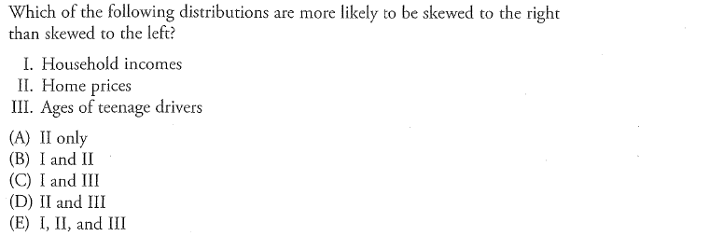

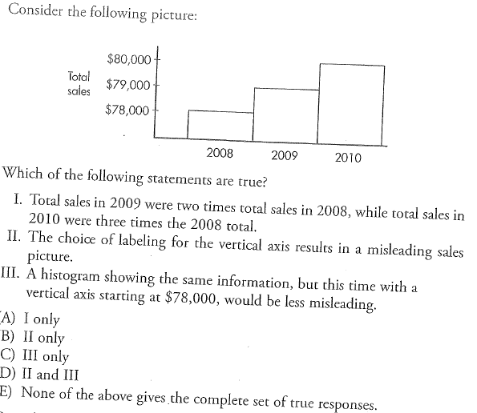

Free Response – Show all your work. Indicate clearly the methods you use, because you will be graded on the correctness of your methods as well as the accuracy and completeness of your results and explanations. Each question will be assessed on a four-point holistic scoring rubric, which both evaluates the accuracy of your statistical methods and the clarity of your communication.
