Alg 2B - Standard 6 Review

Name:

**6.1 Graph a circle from an equation**

1. Graph ${(x-3)}^{2}+{(y+7)}^{2}=4$

Center:

Radius:



1. Graph $x²+y²=64$

Center:

Radius:

1. ****Graph ${(x+4)}^{2}+{(y-5)}^{2}=25$

Center:

Radius:

**6.2 Write the equation of the circle**

Write an equation given the center and radius.

1. Center (15, -4) r = 10
2. Center (-18, 2) r = 39
3. Center (13, 19) r = 27
4. Center (-615, -74) r = 1

Write in standard form, then give the center and radius.

$x^{2}-8x+y^{2}+22y=34$

1. x + 12x - 20y = - y- 16

Given the area or circumference with the center, write and equation

1. Center (7, -13) $A=32π$
2. Center (-18, 15) $C=32π$
3. Center (79, -41) $C=31π$
4. Center (-2, -1) $A=15π$
5. Write the equation of the circle below.

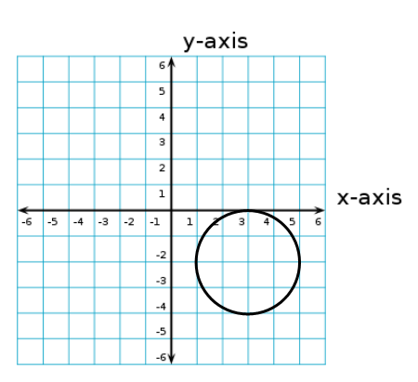

**6.3 Write the equation of a circle given a translation**

1. ${(x-42)}^{2}+{(y+7)}^{2}=14$ translate left 9, and down 6
2. ${(x+9)}^{2}+{(y-3)}^{2}=4$ translate right 1, and up 7
3. ${(x-44)}^{2}+{(y-18)}^{2}=74$ translate right 9, and up 6
4. ${(x+22)}^{2}+{(y-62)}^{2}=42$ translate right 12, and down 10

**6.4A Write the equation of a circle given the ends of a diameter**

1. diameter ends (2, 12) and (-4, 16)
2. diameter ends (19, 12) and (-11, 8)

**6.4B Write the equation of a circle given the center and a point on the circle**

1. Center (4, 7) Point (-9, 13)
2. Center (15, -12) Point (2, -5)

**6.5 Graph an ellipse from an equation**

1. Graph, then answer the questions 
   1. What is the center?
   2. What are the vertices?
   3. What are the co-vertices?
2. Graph, then answer the questions 
3. What is the center?
4. What are the vertices?
5. What are the co-vertices?