Syllabus Intermediate Algebra A

Byrd Email: nbyrd@scappoose.k12.or.us
LoPriore Website: KLoMath.weebly.com

Expectations

A productive and respectful classroom environment is essential for learning. Individual behavior can support or undermine the learning environment. To make our classroom work well, here is what is expected of you:
- Be ready for the beginning of class when the bell rings by having homework ready to be checked and following directions promptly.
- Bring your pencil, notebook, book, and calculator to class every day.
- Listen silently when it is someone else’s turn to talk.
- No cell phones/ipods etc. will be allowed to be used during instructional time or they will be confiscated.
- Stay focused on the current learning activity and put forth your best effort.
- Follow all school rules.
In general, these expectations will be upheld with consequences that begin with verbal warnings, and progress to detentions or school-level discipline for serious or repeated offenses.

Grade Weights

Assessments– 70 %
- Tests and exams will be administered to all students at the same time. Alternative assessment times will only be offered to students with excused absences.
- All students have one opportunity to retake standard tests, but not midterm or final exams. There will be a strict 2 week opportunity window for each standard.
- If you elect to take retake a standard, both scores will contribute to your grade.
- This category may also include any alternative assessments, such as major projects.
Assignments & Practice – 15%
- Independent Practice is an essential part of learning. Assignments should be labeled, organized, and clearly show all work. Be prepared to submit your work for checking. Students are encouraged to check odd answers in the back of the book. Late assignments will only earn up to proficiency (7/10). Late assignments are only accepted until the date of the standard test on that unit.
Learning Target Quizzes – 15%
- Quizzes are an opportunity for students to get feedback on their proficiency within a specific learning target.
Grade Scale

A - 90% and higher C - 70% and higher F - 59% and below
B - 80% and higher D - 60% and higher

Students with 60% or higher earn credit.

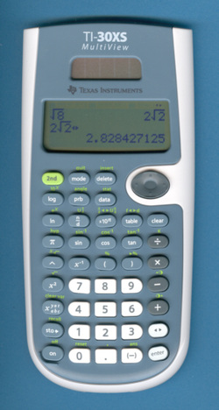

Materials

- Binder or Spiral notebook
- Math Folder
- Pencil with eraser
- Calculator (suggested TI-30XS)
- textbook

Extra Help/Tutorial

Extra help will be available most days both before and after school. The easiest way to get help – ASK!!
Students that do not demonstrate proficiency may be required to work outside of classroom time.

Website

Please visit the website for information about the class and links to useful resources.

Classroom

No food or drinks may be consumed in the classroom, except water. Please clean up your workspace before you leave each day (including the floor). There should be absolutely no writing on desks, walls, or other parts of the classroom. Remain in your seat until the bell rings.

