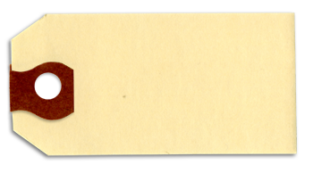
Buckley Farms produces homemade potato chips that it sells in bags labeled “16 ounces”. The total weight of each bag follows an approximately Normal distribution with a mean of 16.15 ounces and standard deviation 0.12 ounces.
Chapter
6
- If you randomly selected 1 bag of these chips, what is the probabilty that the total weight is less than 16 ounces?
“FRAPPY”
{Free Response AP Problem...Yay!}
The following problem is modeled after actual AP Statistics free response questions.
Your task is to generate a complete, concise statistical response in 15 minutes. You will be graded based on the AP rubric and will earn a score of 0-4. After grading, keep this problem in your binder for your AP Exam preparation.
E P I
Total:__/4
- If you randomly selected 10 bags of these chips, what is the probabilty that exactly 2 of the bags will have a total weight is less than 16 ounces?
“FRAPPY”
{Free Response AP Problem...Yay!}
The following problem is modeled after actual AP Statistics free response questions.
Your task is to generate a complete, concise statistical response in 15 minutes. You will be graded based on the AP rubric and will earn a score of 0-4. After grading, keep this problem in your binder for your AP Exam preparation.
E P I
Total:__/4
- Buckley Farms ships its chips in boxes that contain 6 bags. The empty boxes have a mean weight of 10 ounces and a standard deviation of 0.05 ounces. Calculate the mean and standard deviation of the total weight of the box containing 6 bags of chips.
E P I
- Buckley Farms decides to increase the mean weight of each bag of chips so that only 5% of the bags have weights that are less than 16 ounces. Assuming that the standard deviation remains 0.12 ounces, what mean weight should they use?
E P I

