Algebra 2B – Final Review

1. Write an equation given the center and radius.

Center (-6, 14) r = 12

1. Write in standard form, and then give the center and radius.
$$x^{2}-10x+y^{2}+18y=34$$

2. Translate the following equation

${(x+16)}^{2}+{(y-9)}^{2}=74$ translate right 18, and down 10

1. Given the area or circumference with the center, write and equation
   1. Center (17, -5) $A=28π$
   2. Center (-1, 22) $C=28π$
2. Given the diameter ends, write an equation

(-6, 11) and (-12, 7)

1. Write the equation of a circle with the given center and point on the circle

Center (-5, 8) Point (-7, -11)

1. Graph ${(x-3)}^{2}+{(x+1)}^{2}=16$



1. Given , . and 
   1. 
   2. 
   3. 
2. Given , . and 
   1. 
   2. 
   3. 
   4. 
3. Given a graph, sketch the inverse function. (hint- make two tables)

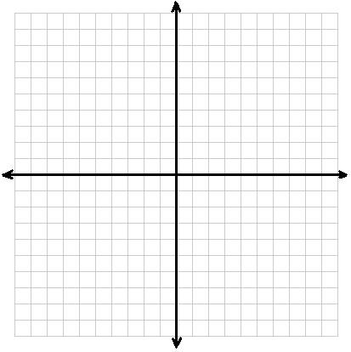

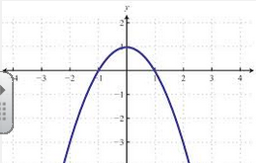

1. Given ordered pair, add, subtract, multiply, divide, and find the composite.

f: (3, 10) (4, -11) (7, 6) (12, 9)

g: (-2, 12) (3, 12) (5, 9) (12, 16)

h: (3, 6) (5, -4) (7, -4) (10, -2)

1. 
2. 
3. 
4. 
5. 
6. Given an equation, find the inverse.
7. 
8. 
9. 
10. 
11. 
12. 
13. Describe the relationship between the functions  and .
14. Rewrite  in logarithmic form.
15. Rewrite  in exponential form.
16. Simplify by rewriting as a single logarithm.



1. Expand and rewrite using properties of logs.



Solve each equation. Where necessary, round answers to the nearest hundredth.

1. 
2. 
3. 
4. 
5. 
6. The cost of a house is increasing at the rate of 2.2% each year.
7. If the house costs $105,000 today, what will the value be in 5 years.
8. How long will it take for the house to double in value? Write and equation and solve.
9. The population of Taegu, South Korea, was about 2.65 million in 1991 and was projected to **decrease** at a 3.77% annual rate from 1991 to 1995. Predict the population of Taegu in 1995.
10. Rewrite with rational exponents and evaluate. If necessary, round answers to the hundreths place.

a.  b. 

1. Rewrite in racidal form and evaluate. If necessary, round answers to the hundreths place.

a.  a. 

1. Factor
2. 
3. 
4. 
5. 
6. 
7. 

**Simplify rational expressions**

1. 
2. 
3. 
4. 