Chapter 10 Homework
1. One of the two fire stations in a certain town responds to calls in the northern half of the town, and the other fire station responds to calls in the southern half of the town. One of the town council members believes that the two fire stations have different mean response times. Response time is measured by the difference between the time an emergency call comes into the fire station and the time the first fire truck arrives at the scene of the fire.

Data were collected to investigate whether the council member’s belief is correct. A random sample of 50 calls selected from the northern fire station had a mean response time of 4.3 minutes with a standard deviation of 3.7 minutes. A random sample of 50 calls selected from the southern fire station had a mean response time of 5.3 minutes with a standard deviation of 3.2 minutes.

(a) Construct and interpret a 95 percent confidence interval for the difference in mean response times between the two fire stations.

(b) Does the confidence interval in part (a) support the council member’s belief that the two fire stations have different mean response times? Explain.

2. A large pet store buys the identical species of adult tropical fish from two different suppliers—Buy-Rite Pets and Fish Friends. Several of the managers at the pet store suspect that the lengths of the fish from Fish Friends are consistently greater than the lengths of the fish from Buy-Rite Pets. Random samples of 8 adult fish of the species from Buy-Rite Pets and 10 adult fish of the same species from Fish Friends were selected and the lengths of the fish, in inches, were recorded, as shown in the table below.

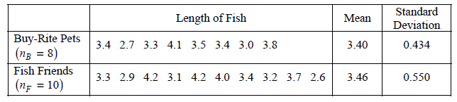

Do the data provide convincing evidence that the mean length of the adult fish of the species from Fish Friends is greater than the mean length of the adult fish of the same species from Buy-Rite Pets?

3. A French study was conducted in the 1990s to compare the effectiveness of using an instrument called a cardiopump with the effectiveness of using traditional cardiopulmonary resuscitation (CPR) in saving lives of heart attack victims. Heart attack patients in participating cities were treated with either a cardiopump or CPR, depending on whether the individual’s heart attack occurred on an even-numbered or an odd-numbered day of the month. Before the start of the study, a coin was tossed to determine which treatment, a cardiopump or CPR, was given on the even-numbered days. The other treatment was given on the odd-numbered days. In total, 754 patients were treated with a cardiopump, and 37 survived at least one year; while 746 patients were treated with CPR, and 15 survived at least one year.

(a) The conditions for inference are satisfied in the study. State the conditions and indicate how they are satisfied.

(b) Perform a statistical test to determine whether the survival rate for patients treated with a cardiopump is significantly higher than the survival rate for patients treated with CPR.

4. A researcher wants to conduct a study to test whether listening to soothing music for 20 minutes helps to reduce diastolic blood pressure in patients with high blood pressure, compared to simply sitting quietly in a noise-free environment for 20 minutes. One hundred patients with high blood pressure at a large medical clinic are available to participate in this study.

(a) Propose a design for this study to compare these two treatments.

(b) The null hypothesis for this study is that there is no difference in the mean reduction of diastolic blood pressure for the two treatments and the alternative hypothesis is that the mean reduction in diastolic blood pressure is greater for the music treatment. If the null hypothesis is rejected, the clinic will offer this music therapy as a free service to their patients with high blood pressure. Describe Type I and Type II errors and the consequences of each in the context of this study, and discuss which one you think is more serious.

