Algebra IIA –LoPriore Website: KLomath.weebly.com

Expectations

A productive and respectful classroom environment is essential for learning. Individual behavior can support or undermine the learning environment. To make our classroom work well, here is what is expected of you:
- Be ready for the beginning of class when the bell rings by having homework ready to be checked and following directions promptly
- Bring your pencil, binder/worksheets, and calculator to class everyday
- Listen silently when it is someone else’s turn to talk
- No cell phones/ipods etc. will be allowed to be used during instructional time or they will be confiscated
- Stay focused on the current learning activity and put forth your best effort
- Follow all school rules
In general, these expectations will be upheld with consequences that begin with verbal warnings, and progress to detentions or school-level discipline for serious or repeated offenses.

Grade Scale
A - 90% and higher C - 70% and higher
B - 80% and higher F - 69% and below

Students must demonstrate a proficiency level of 70% or higher twice on each standard and pass the final exam in order to pass the class. Students will have multiple opportunities to pass Standards.

Grade Weights
Students must demonstrate a proficiency level of 70% or higher twice on each standard, including the final exam, in order to pass the class.

Standards – 70 %
- In order to take the additional opportunity outside of class to pass standards, students are required to complete additional practice/review assignments and tutorial. Parents will be contacted if a student scores below 70%.

Assignments & Practice – 5%
- Clearly show all work. Be prepared to submit your work for checking.

Final Exam – 20%
- Must pass at 70% or higher to demonstrate proficiency and retention across standards

Learning Target Quizzes – 5%
- Quizzes are an opportunity for students to get feedback on their proficiency with any given learning target. If students do not demonstrate proficiency they will be assigned additional practice and/or a writing assignment to reinforce learning.
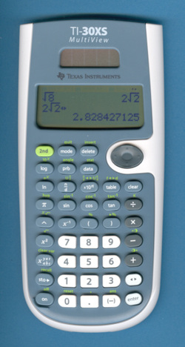
Materials

- 1 inch 3-ring binder
- Pencil with eraser
- Calculator (suggested TI-30XS)

Extra Help/Tutorial

I will be available for extra help each day after school. Morning help can be made by appointment. The easiest way to get help – ASK!! Students that do not demonstrate proficiency will be required to attend tutorials and/or study groups.

Website

Please visit the website for information about the class and links to useful resources.
KLomath.weebly.com

Hall Passes

Students will be given one pass per term. With teacher permission, students may leave the classroom up to 5 times for locker or bathroom visits. If the slip is lost, no replacement will be given. I will hole-punch the card with each use. Students will turn in their slip at the end of the term. Any remaining, unused visits will each be translated into extra credit points.
You need to be in the classroom to learn, so plan ahead!

Classroom

No food or drinks may be consumed in the classroom, except water. Please clean up your workspace before you leave each day (including the floor). There should be absolutely no writing on desks, walls, or other parts of the classroom. Remain in your seat until the bell rings.

