Name Date
Standard 6 Review: Systems

1. Indicate (yes/no) whether the given point is a solution to the system.

a. 5x + 3y = -5 (2,-5) b. y = 3x – 2 (2, 4)
2x – 2y = 16 y = ¹/₂x + 3

2. Sketch a graph of a system with each of the following number of solutions.

a. Zero solutions b. One Solution c. Two solutions d. ∞ solutions

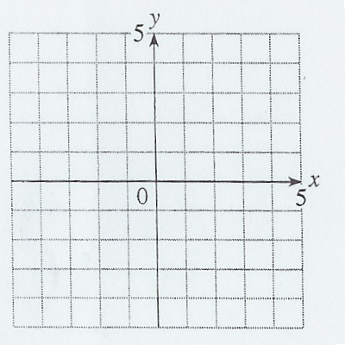

3. Solve the following systems of linear equations by graphing.

a. x = -3 b. 2x + y = 4

y = -4 -3x + 3y = 3

Solution: Solution:

c. y = 2x + 1 d. y = -2x + 1

y = -¹/₂x – 4 4x + 2y = 4

Solution: Solution:

4. Decide which method is best for solving the following systems. Explain why.

a. y = 2x – 8 b. 4x – 2y = 4
3x – 5y = 7 9x + 2y = 80

5. Solve the following systems with Substitution. Show your work.

a. x = 3 b. y = 3x – 2

3x – 5y = 4 y = 2x + 3

Solution: Solution:

c. 4y – 8 = x d. 6x – 2y = 16

3x – 5y = 11 y = x + 2

Solution: Solution:

6. Solve the systems with Linear Combination. Show your work.

a. 3x + 2y = -2 b. 4x – 3y = 11

-3x + 5y = -26 2x + 6y = 28

Solution: Solution:

c. 4x + 2y = 8 d. 5x – 3y = 11

5x + 7y = 1 3x + 4y = 24

Solution: Solution:
7. Solve the systems. Use any method.

a. -4x + 6y = -5 b. x = 3 – y
4x – 6y = 5 2x + 2y = 1

Solution: Solution:

8. MacDonald’s is having a burger sale. On Sunday you buy 11 hamburgers and 8 cheeseburgers and spend $36.50. Today so you buy 15 hamburgers, 4 cheese-burgers and spend a total of $32.50.

a. Define your variables and write a system of linear equations for this situation.

b. Solve your system to find out how much it costs for a hamburger and how much a cheeseburger costs. Show your work.

9. The cafeteria is going to start selling Tornados (like Blizzards®, but different enough we won’t get sued). it costs $287 to buy the machine and $1.50 per serving to make them. They plan to charge $3.00 per serving.

a. Define your variables and write a system of linear equations for this situation.

b. Solve your system to find the break-even point. Show your work.

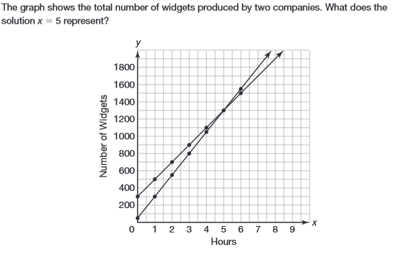
10.

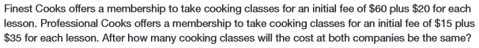
11.

12.

13. Indicate whether the graph of the inequality would be represented with a solid or dotted line.

a. 5x + 3y > -5 b. y ≤ 3x – 2 c. x = 6 d. y < 4x

14. Indicate whether the following points are solutions to the inequality: 3x + 2y ≤ 7

a. (0, 0) b. (1, 4) c. (3,-2) d. (-3, 4)

15. Indicate whether the following points are solutions to the inequality: y > 3x – 1

a. (0, 0) b. (1, 4) c. (3,-2) d. (-2, -6)

16. Indicate whether the following points are solutions to the system: x < 13
y ≥ -9
a. (13, 2) b. (10, 4) c. (5,-9)

17. Indicate whether the following points are solutions to the system: y ≤ -¹/₂x + 5
3x – 2y > 5
a. (0, 0) b. (1, 2) c. (4, 3)

18. Indicate whether the following points are solutions to the system: x ≤ 2
y < 3
a. (0, 0) b. (2, 2) c. (1, 4) y > 4x − 1

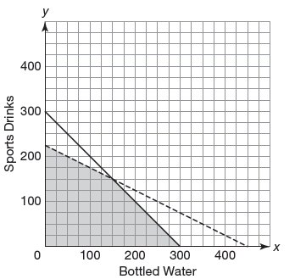

19. Indicate whether the following points are solutions to the
graph the system:

a. (0, 0) b. (50, 200) c. (200, 100)

20. Solve the following systems of linear inequalities by graphing.

a. x > -2 b. x ≤ 0

y ≤ 3 y > 0

c. x > -3 d. 2x + y ≥ 4

y ≥ x -2x + 2y < 4

e. y < 2x + 1 f. y ≥ -2

y ≤ -¹/₂x – 4 y < 2x + 3

4x + 2y ≤ 8

g. y < 4 h. x ≥ -4

y ≥ -3 y < 3

x > -2 y ≤ x – 1

x ≤ 1

21. The Seahawks are planning to win the Superbowl. They are so confident that they aren’t even going try to score any touchdowns. Safeties are worth 2 points and field goals are 3 points. Show your work.

a. How much will they score if they get 2 safeties and 3 field goals?

b. How much will they score if they get 3 safeties and 4 field goals?

Pete Carroll believes if the Seahawks score more than 12 points, they will win. Use x for safeties and y for field goals.

c. Write an inequality for this situation?

d. Would they reach their goal in either of the situations above?

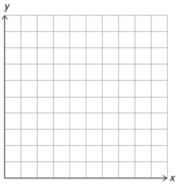
e. Graph your inequality from 2a.
Label your axes.

f. According to your graph, if they
score 3 safeties and kick 2 field
goals, will they meet their goal?

g. According to your graph, Will they
meet their goal if they score
2 safeties and kick 5 fieldgoals?

