Algebra 2 Standard 2 Review Name: Date:
- What is the solution to a system of linear equations?

- Sketch a graph of a system with each of the following number of solutions.
a. Zero solutions b. One Solution c. Two solutions d. ∞ solutions
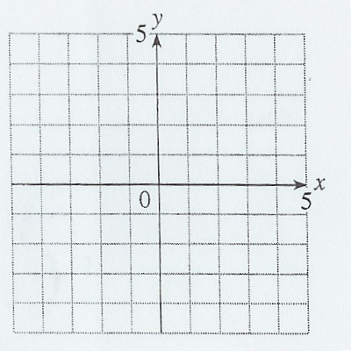

- What is the best method for solving the following systems? Why?
a. y = 3x – 2 b. 4x + 6y = 5
3x + 7y = 4 3x + 5y = 6

- LT 2.1 Students will be able to solve a system of equations by graphing.
a. y = 3x – 5 b. 2x – 3y = 6
y = -¹/₂x + 2 y = x – 1

Solution: ___ Solution:

- LT 2.2 Students will be able to solve a system of equations by substitution.
a. x = 5y b. y = x + 7
2x– 4y = 12 4x + 5y = 8

c) 3x + 6y = 2 d) 2x − y = 4
x = -2y + 4 y = 2x + 3

- LT 2.3 Students will be able to solve a system of equations by elimination.
a. 2x – 2y = 6 b. 2x – 3y = -2
4x + 2y = 12 4x + 5y = 18

c) -3x + 2y = -5 d) 2x + y = 3
6x − 4y = 10 6x + 3y = 10

- LT 2.4 Students will be able to solve application problems involving systems.
Fred Meyer is having a sale. Short sleeve T-shirts are $9 and long sleeve are $12. You spend a total of $96 on 9 items. How many of each type did you buy?
Define variables. Write two equations and solve (show all steps). Write a solution sentence.

LT 2.5 Students will be able to solve linear inequalities and a system of linear inequalities.
- Create the graph of the solution of the given system of inequalities.
Then decide if the following points are solutions (yes/no).
y > 3x – 2
3x + 6y ≤ 12

a. (-1, -5): b. (-4, 2):

c. (-2, 3): d. (4, 3):

- Solve the following systems of linear inequalities.
a. y ≥ 4x – 3 b. 2x + y < 4
y < -2x + 3 y ≥ -3;
x > 1

- Solve the systems. Use any method.
a. 2x – 3y = -2 b. 4x – 3y = 25
y = -4x + 24 -3x + 8y = 10

