Linear Regression Data Study- Beer and BAC

How much alcohol can one consume before one's blood alcohol content (BAC) is above the legal limit? An undergraduate statistics project conducted at The Ohio State University in Columbus, Ohio explored the relationship between BAC and other variables such as amount of alcohol consumed, weight, gender and age.

Protocol The experiment took place in February of 1986 at a student dormitory. Sixteen students volunteered to be the subjects in the experiment. Each student blew into a breathalyzer to indicate that his or her initial BAC was zero. The number (between 1 and 9) of 12 ounce beers to be drunk was assigned to each of the subjects by drawing tickets from a bowl. Thirty minutes after consuming their final beer, students had their BAC measured by a police officer of the OSU police department. The officer also administered a road sobriety test before and after the alcohol consumption. This involved performing four simple tasks, graded on a scale of 1 to 10 (ten being a perfect rating), demonstrating coordination: balancing on one foot, touching the tip of one's nose with a forefinger, placing one's head back with one's eyes closed, and walking heel to toe. The police officer was not aware of how much alcohol each subject had consumed.

ID_OSU | Gend_OSU | Wght_OSU | Beers | BAC | 1st-Sobr | 2nd-Sobr
1 | female | 132 | 5 | 0.1 | 10 | 6
2 | female | 128 | 2 | 0.03 | 9.5 | 9.25
3 | female | 110 | 9 | 0.19 | 9.75 | 4.75
4 | male | 192 | 8 | 0.12 | 10 | 7.5
5 | male | 172 | 3 | 0.04 | 10 | 9.75
6 | female | 250 | 7 | 0.095 | 9.5 | 6.5
7 | female | 125 | 3 | 0.07 | 9.5 | 7
8 | male | 175 | 5 | 0.06 | 9.75 | 8.75
9 | female | 175 | 3 | 0.02 | 9.5 | 6
10 | male | 275 | 5 | 0.05 | 9.75 | 8.5
11 | female | 130 | 4 | 0.07 | 9.5 | 8.5
12 | male | 168 | 6 | 0.1 | 9.5 | 7.75
13 | female | 128 | 5 | 0.085 | 9.75 | 8.25
14 | male | 246 | 7 | 0.09 | 10 | 7.75
15 | male | 164 | 1 | 0.01 | 9.5 | 9.5
16 | male | 175 | 4 | 0.05 | 10 | 9

(a) Make a scatterplot of BAC versus number of beers consumed. Describe what you see.

(b) Use you calculator to compute two-variable statistics. Record the summary statistics below.
(Input Data to L1 and L2, then Stat →Calc→#2: 2-Var Stats)
(d) How strong is the linear association? Find the correlation $r=\frac{1}{n-1}\sum{\left(\frac{x_{i}-\overline{x}}{s_{x}}\right)\left(\frac{y_{i}-\overline{y}}{s_{y}}\right)}$.
(Input Data to L1 and L2, then Stat →Calc→#4 or #8 Lin Reg)
*If r and r² are not displayed, click Mode arrow down to 2nd screen to “stat diagnostics” and turn on. Run Regression again.

(e) Use your calculator to find a linear regression model (see d) for predicting BAC from number of beers consumed. Interpret the slope and y-intercept of the model in context.
Regression Analysis: BAC versus Number of Beers

Predictor Coef SE Coef T P
Constant -0.01270 0.01264 -1.00 0.332
Number of Beers 0.017964 0.002402 7.48 0.000

S = 0.0204410 R-Sq = 80.0% R-Sq(adj) = 78.6%

(f) Use your model from (e) to predict the BAC for a student who consumes 6 beers.

(g) Find and interpret the residual for the student in the study who consumed 6 beers.

(h) The graph below displays the same linear model that you obtained from your calculator. Explain why this model is known as the least-squares regression line.
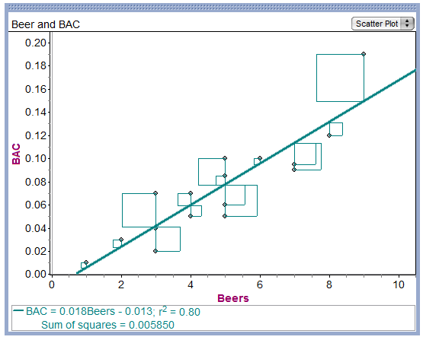
(i) The graph below plots the residual for each of the 16 original data points versus the number of beers consumed. It is known as a residual plot. Describe what you see.
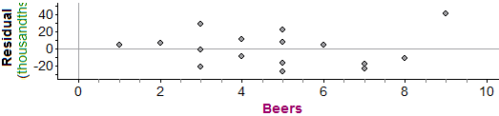

(j) Is a linear model appropriate for describing the relationship between number of beers consumed and BAC? Justify your answer.

How well does the linear model do at predicting BAC from number of beers?

(k) How large is a typical prediction error? Compute $s=\sqrt{\frac{\sum{{residuals}^{2}}}{n-2}}$ and interpret the result.

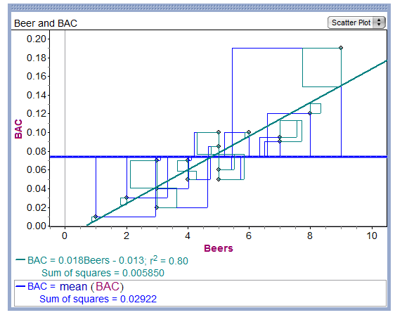

(l) What does $r^{2}$ tell us?

